**PRACTICE-1**

1. **The HR department wants a query to display the ename, job, hiredate, and empno for each employee, with empno appearing first. Provide an alias “STARTDATE” for the HIREDATE column.**

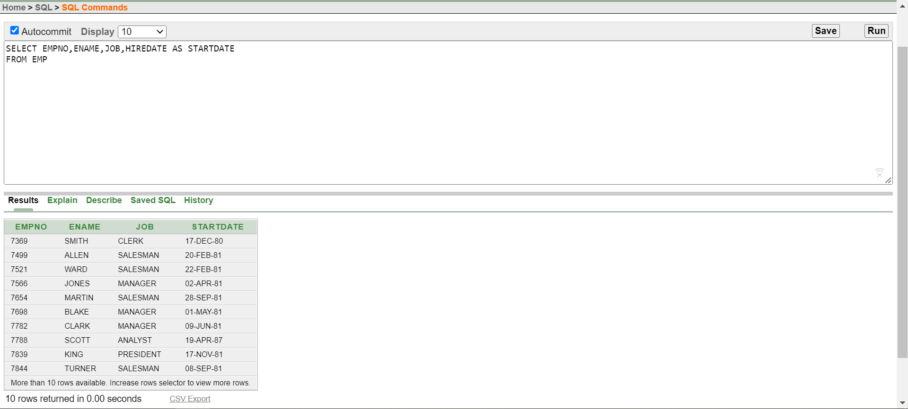

1. **The HR department needs a query to display all unique job from the EMPLOYEES table.**

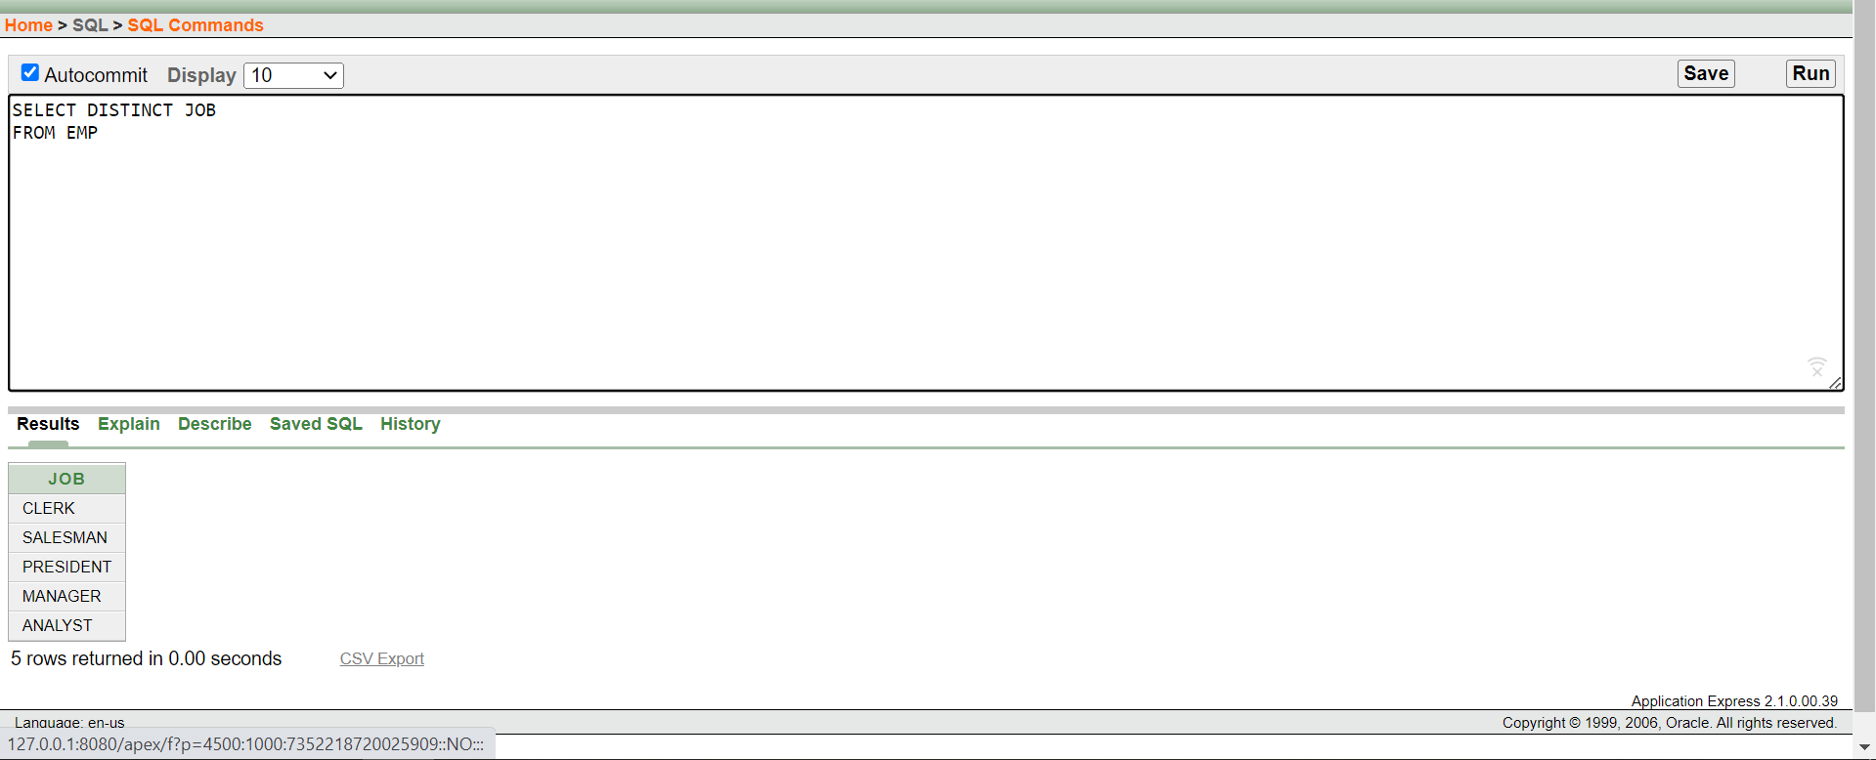

1. **The HR department wants more descriptive column headings for its report on employees. Name the column headings Emp # for empno, Employee for ename, Job for JOB, and Hire Date for HIREDATE, respectively. Then run your query again.**

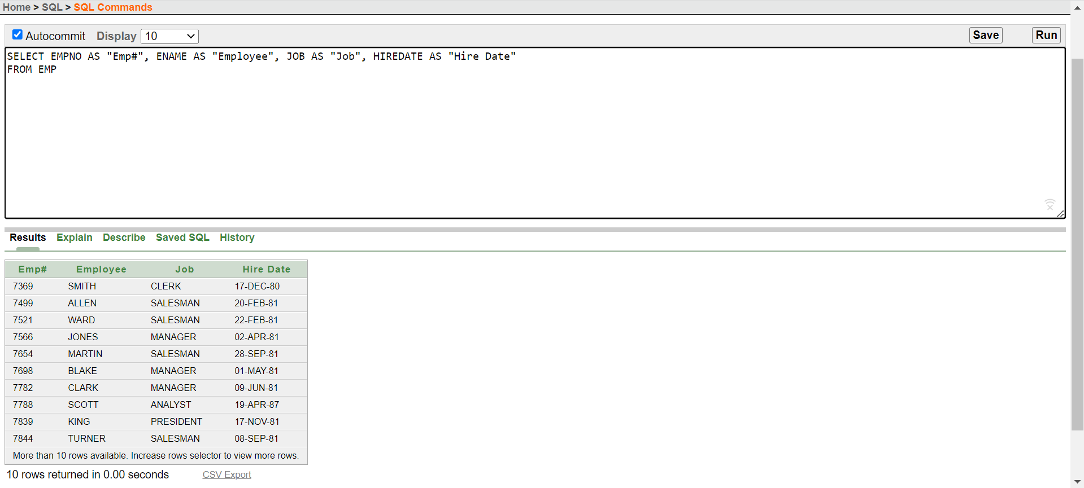

1. **The HR department has requested a report of all employees and their salary. Display the ename concatenated with the salary (separated by a comma and space) and name the column Employee and Title.**

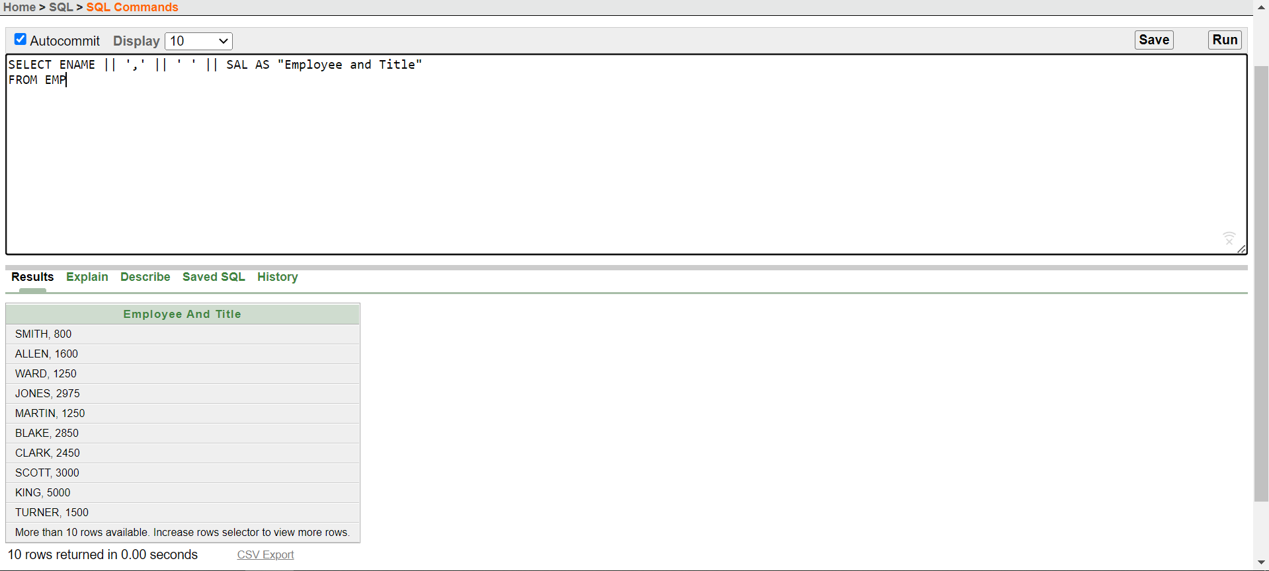

1. **To familiarize yourself with the data in the EMP table, create a query to display all the data from that table. Separate each column output by a comma. Name the column title THE_OUTPUT.**

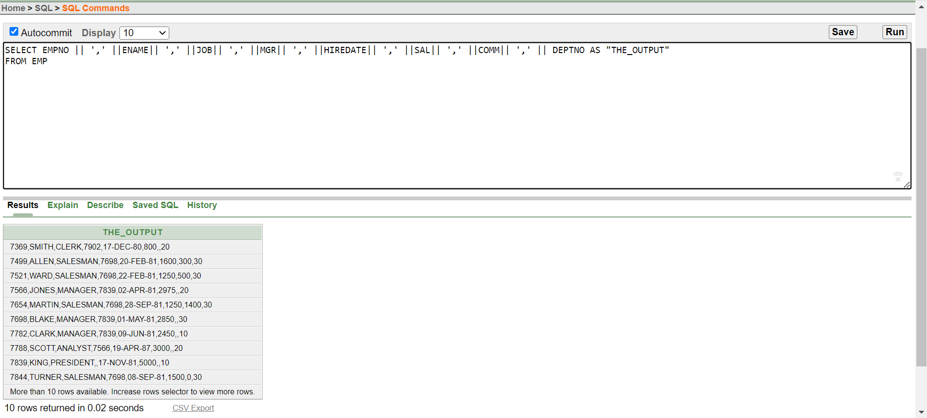

1. **List the deptno from emp uniquely.**

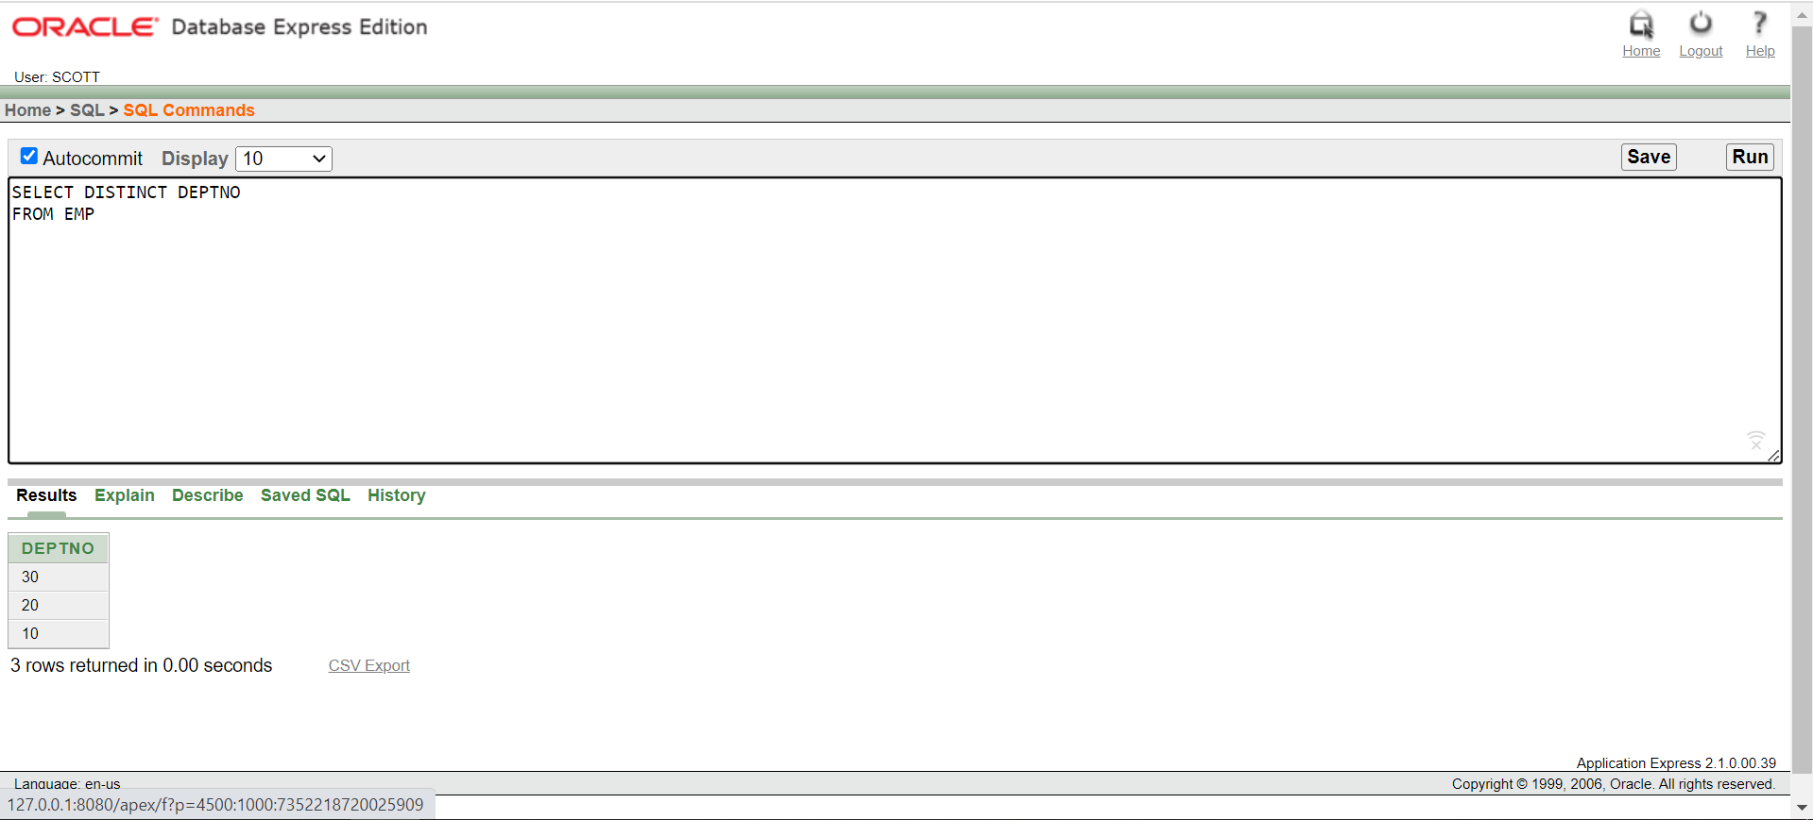

1. **Show the information of all employees like “SMITH go salary $ 800”.**

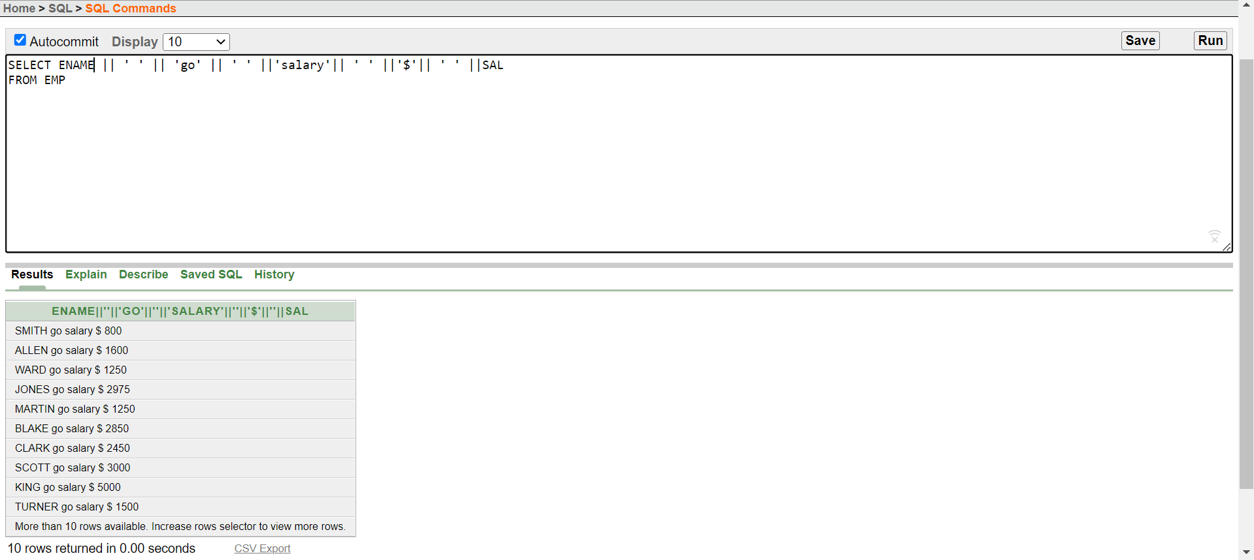

1. **Check whether all the empno are indeed unique.**

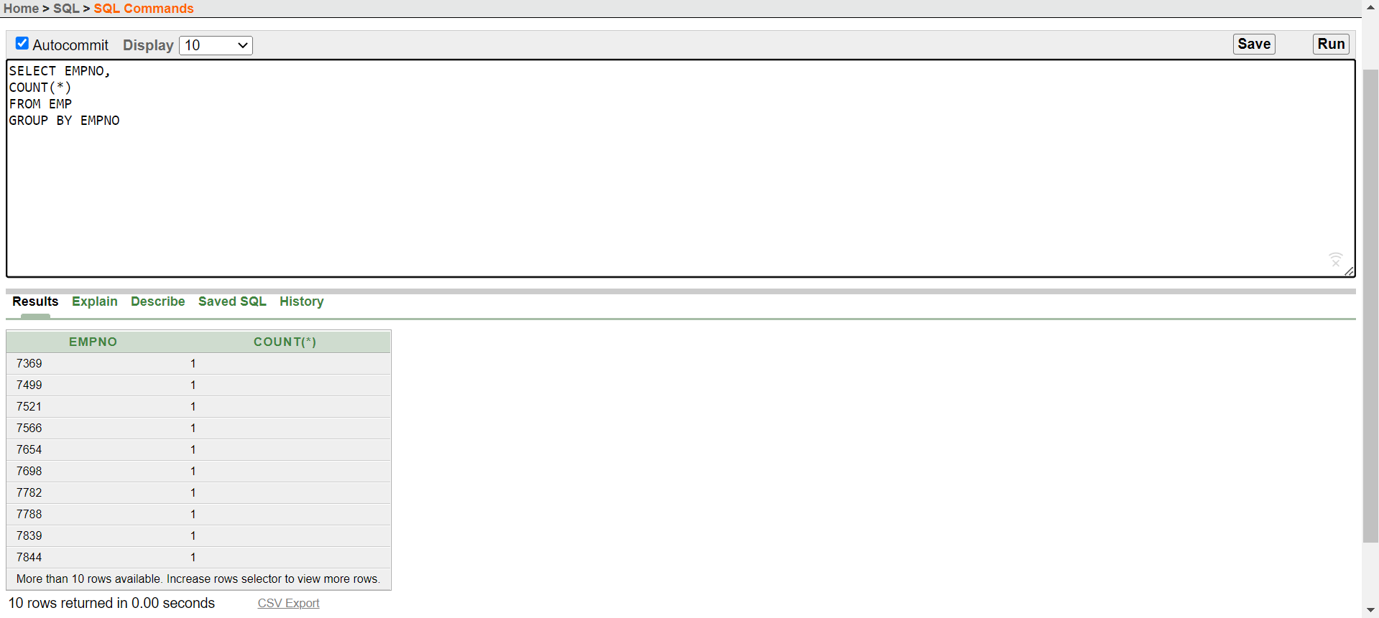

1. **List “Annual salary” for all employee use column aliasing.**

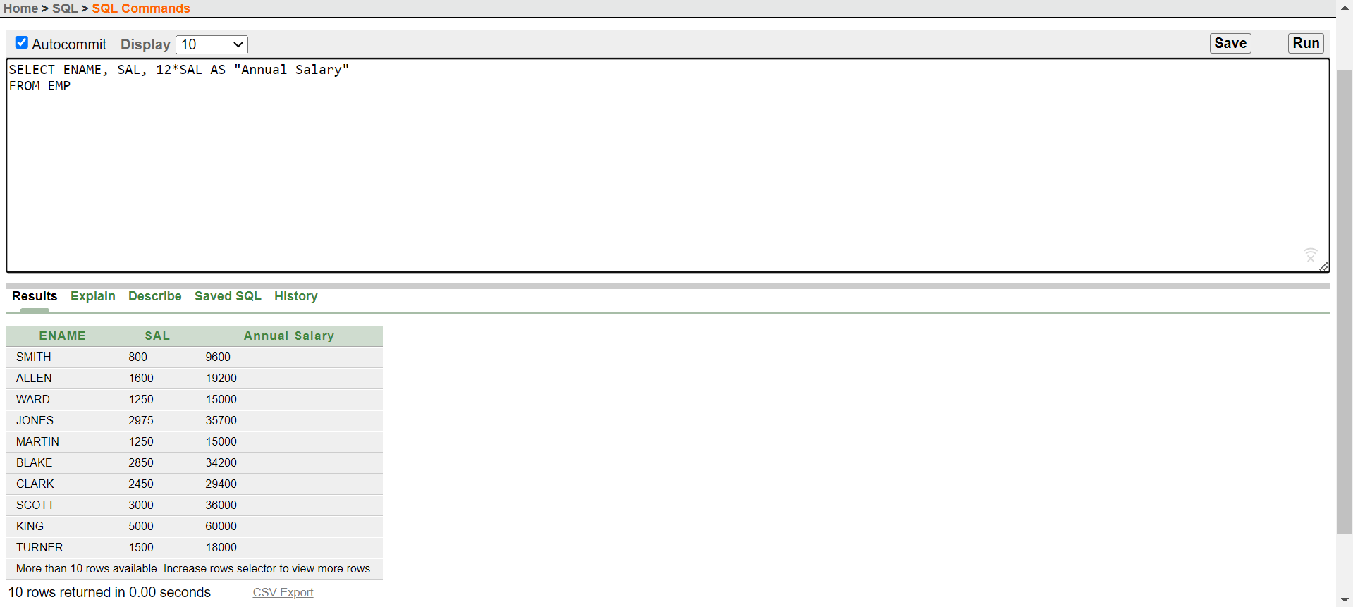

1. **List the information for all employee whose job is either MANAGER or ANALYST.**

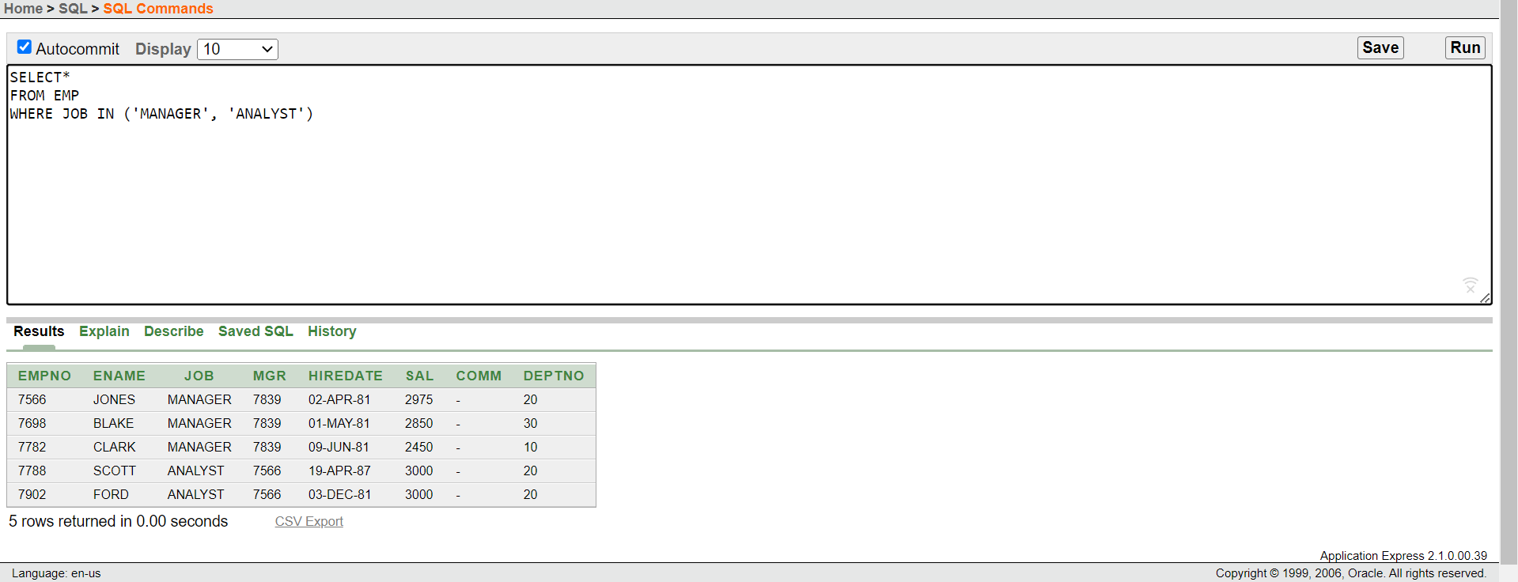

1. **List the department name whose department no is 20.**

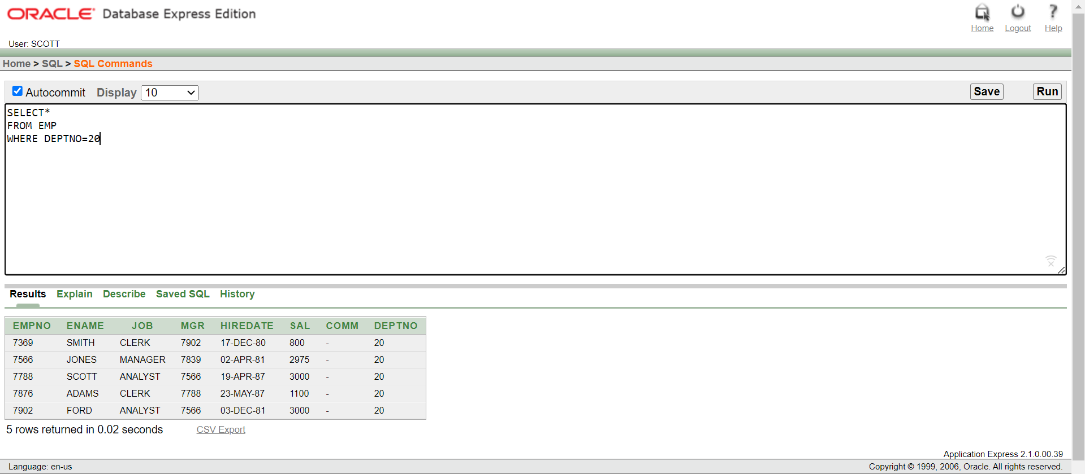

**PRACTICE-2**

1. **Create a query to display the name,salary,commision of employees earning more than $2850.**

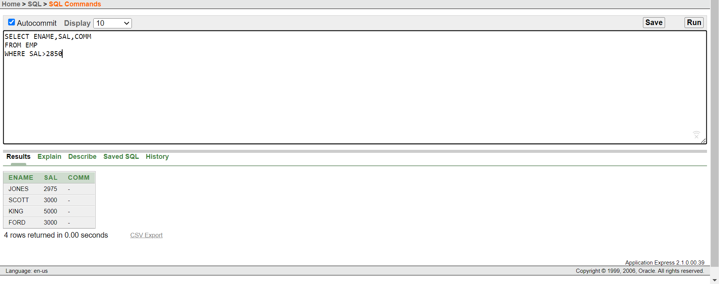

1. **Create a query to display the employee name,salary and department number for employee number 7566.**

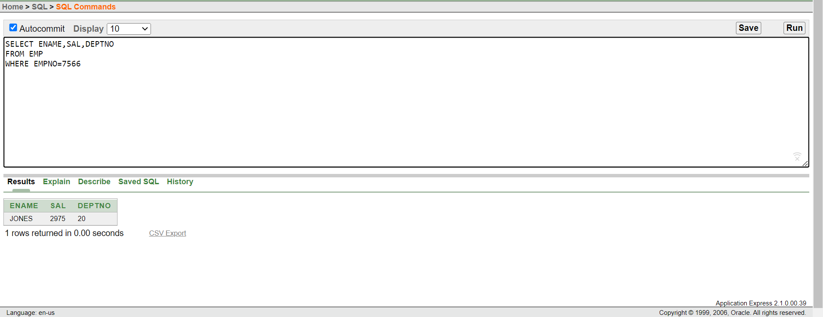

1. **Display the name and salary for all employees whose salary is not in the range of $1500 and $2850.**

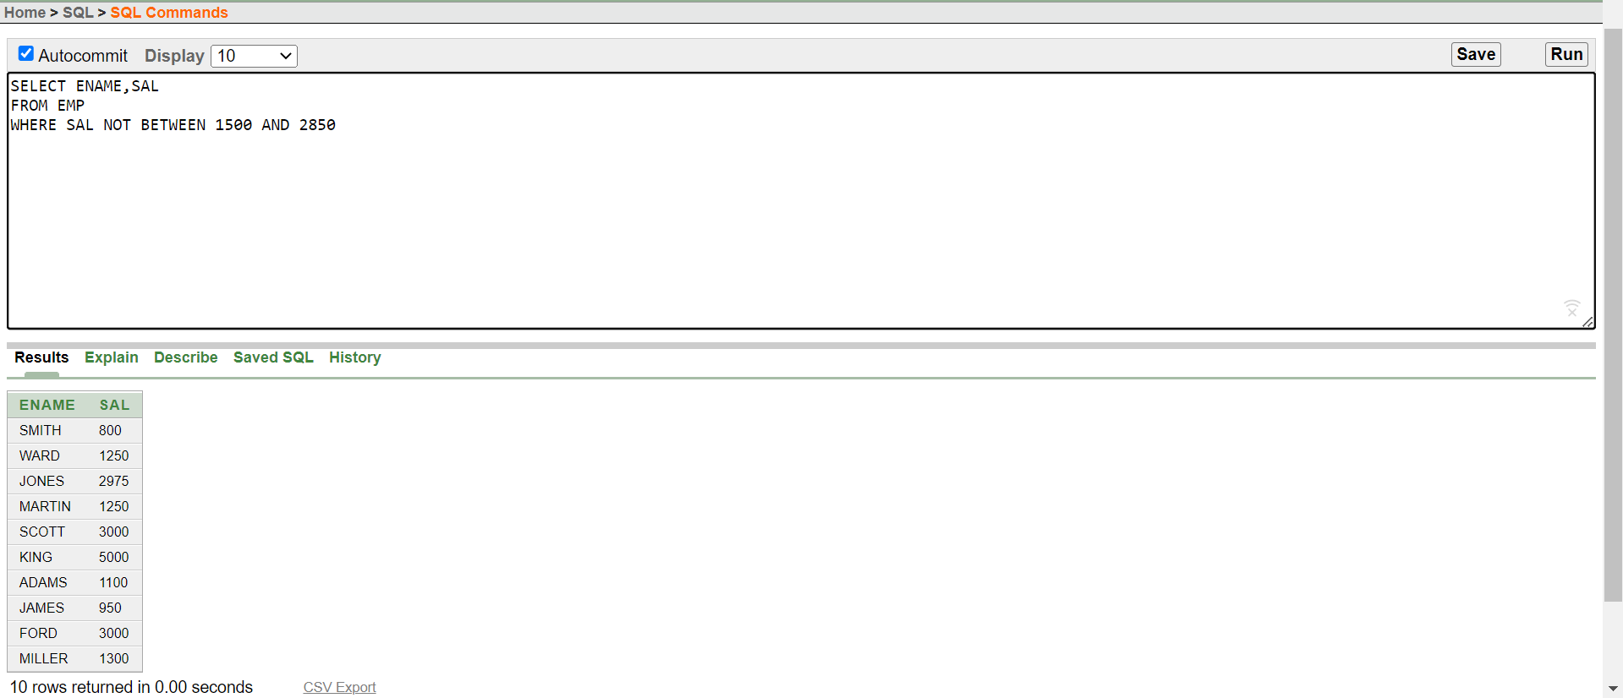

1. **Display the employee name, job, and start date of employees hired between February 20, 1981, and May 1, 1981. Order the query in ascending order by start date.**

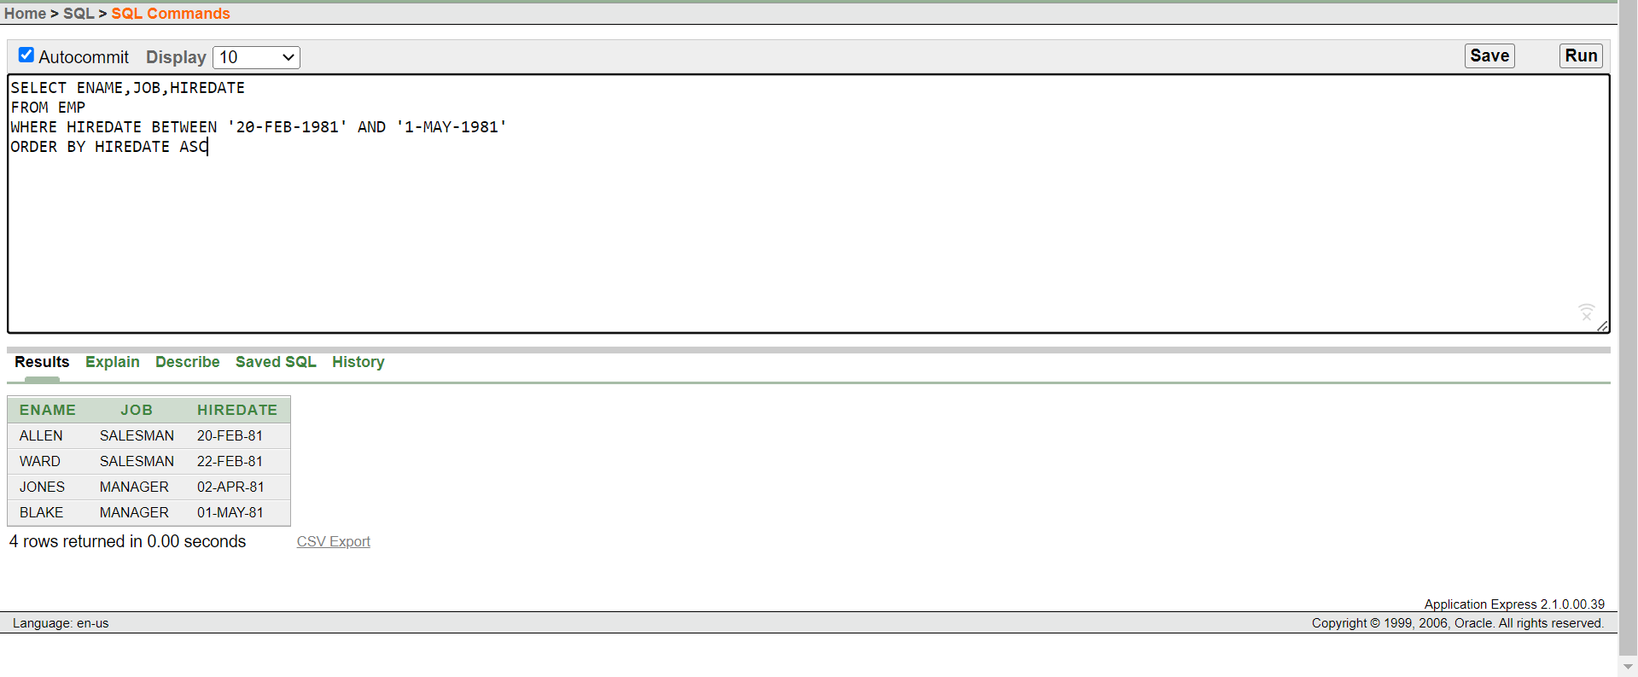

1. **Display the employee name and department number of all employees in departments 10 and 30 in alphabetical order by name.**

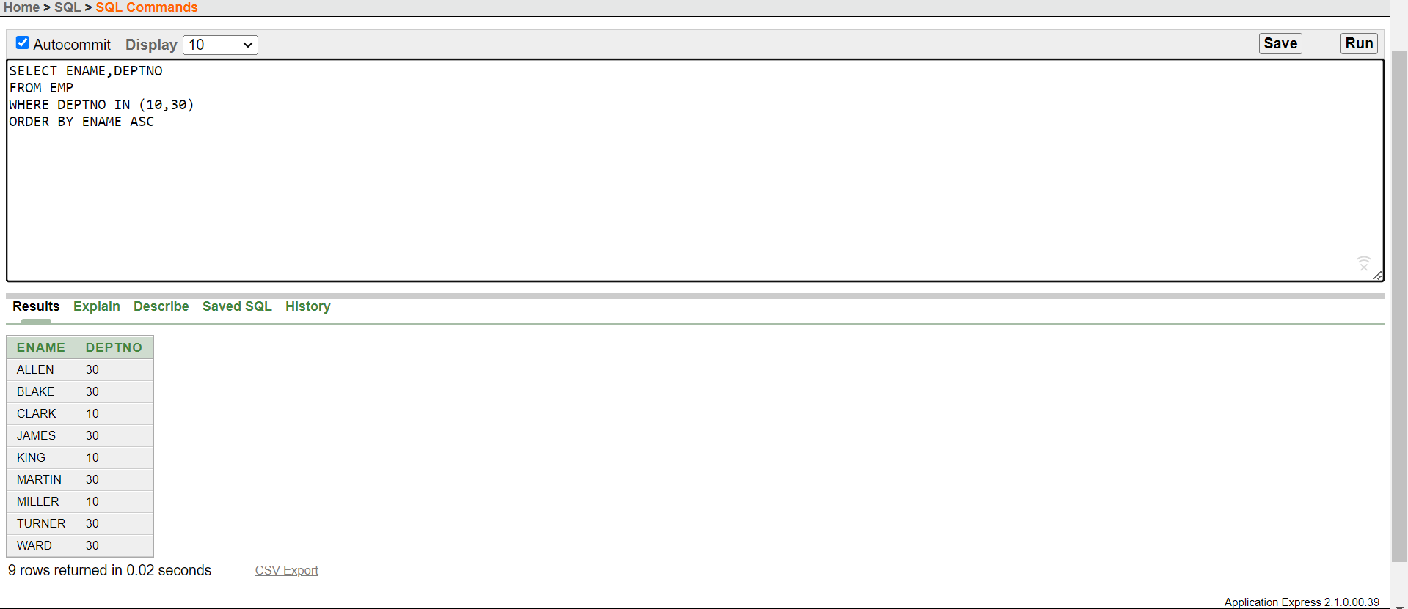

1. **Display list the name and salary of employees who earn more than $1500 and in department 20 or 30. Label the columns Employee and Monthly Salary, respectively.**

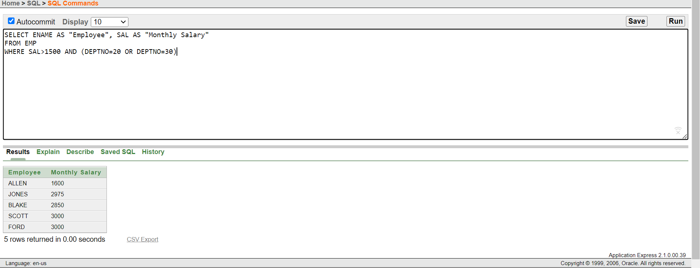

1. **Display the name and hire date of every employee who was hired in 1982.**

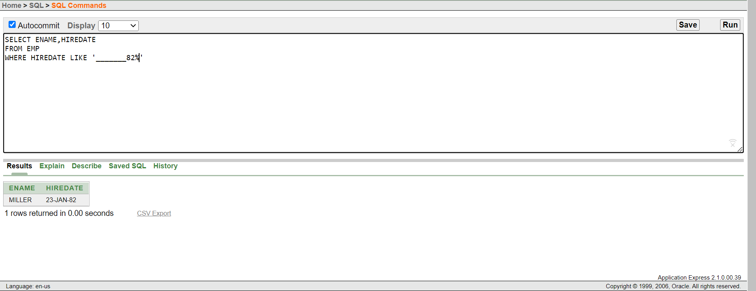

1. **Display the name and job title of all employees who do not have a manager.**

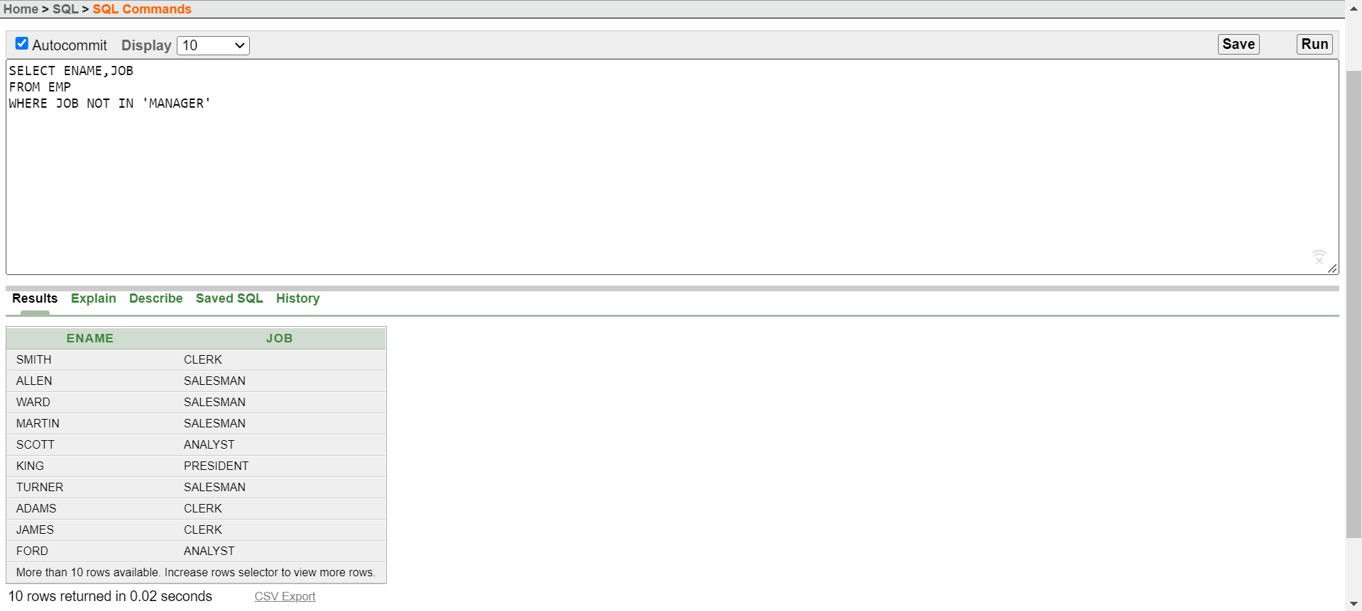

1. **Display the name, salary, and commission for all employees who earn commissions. Sort data in descending order of salary and commissions.**

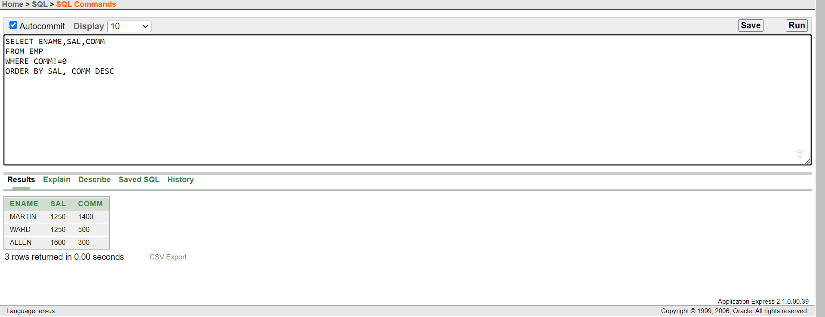

1. **Display the names of all employees where the third letter of their name is an *A*.**

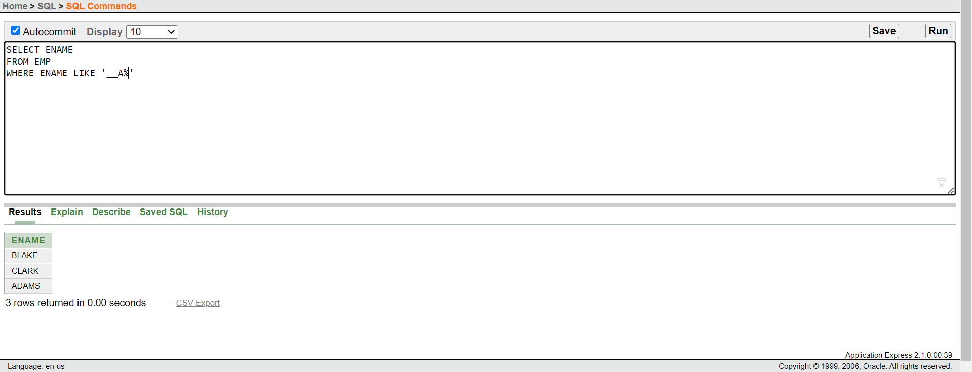

1. **Display the name of all employees who have two Ls in their name and are in department 30 or their manager is 7782.**

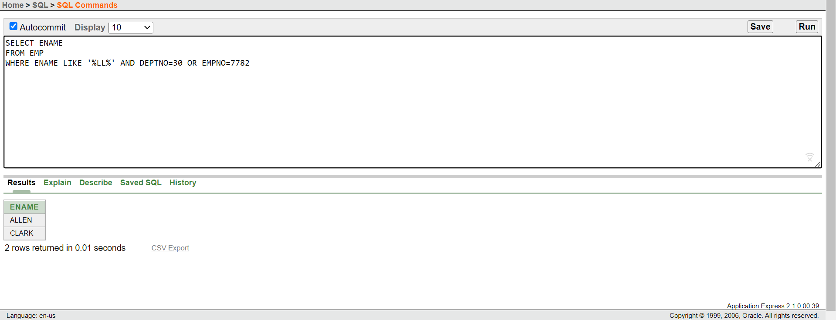

1. **Display the name, job, and salary for all employees whose job is Clerk or Analyst and their salary is not equal to $1000, $3000, or $5000.**

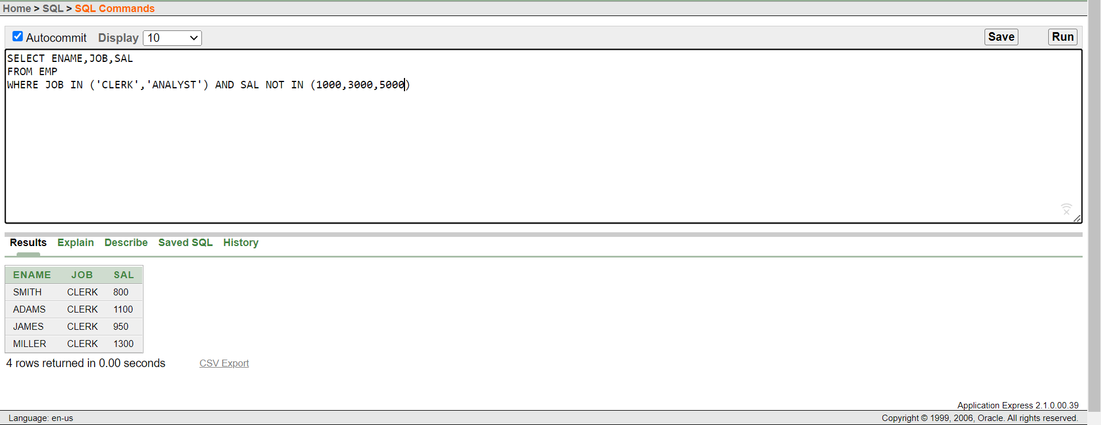

1. **Display the name, salary, and commission for all employees whose commission amount is greater than their salary increased by 10%.**

